**EASY:**

1. Write a C++ program to declare and initialize a constant integer with value 10.

**Program:**

#include<iostream>

using namespace std;

int main(){

const int a=10;

cout<<"The value of constant is :"<<a;

}

**Output:**

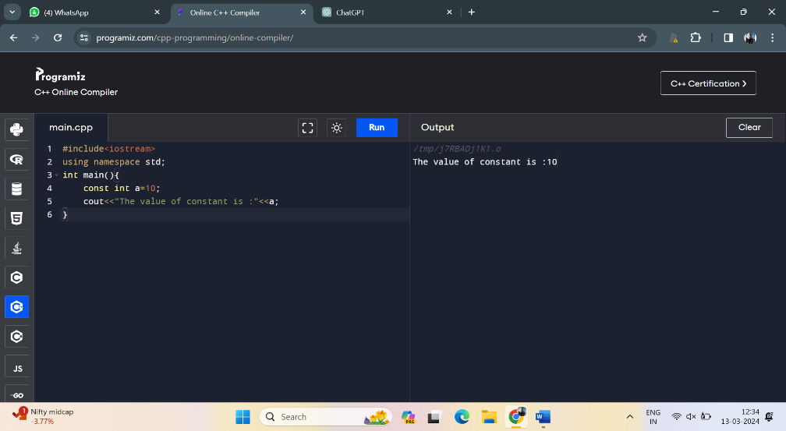

2. Write a C++ program to demonstrate the use of integer, float, and character data types

**Program:**

#include<iostream>

using namespace std;

int main(){

int a=10;

cout<<"integer data type is:"<<a<<"\n";

float b=3.14;

cout<<"float datatype is :"<<b<<"\n";

char c='A';

cout<<"character data type is:"<<c;

return 0;

}

**Output**:

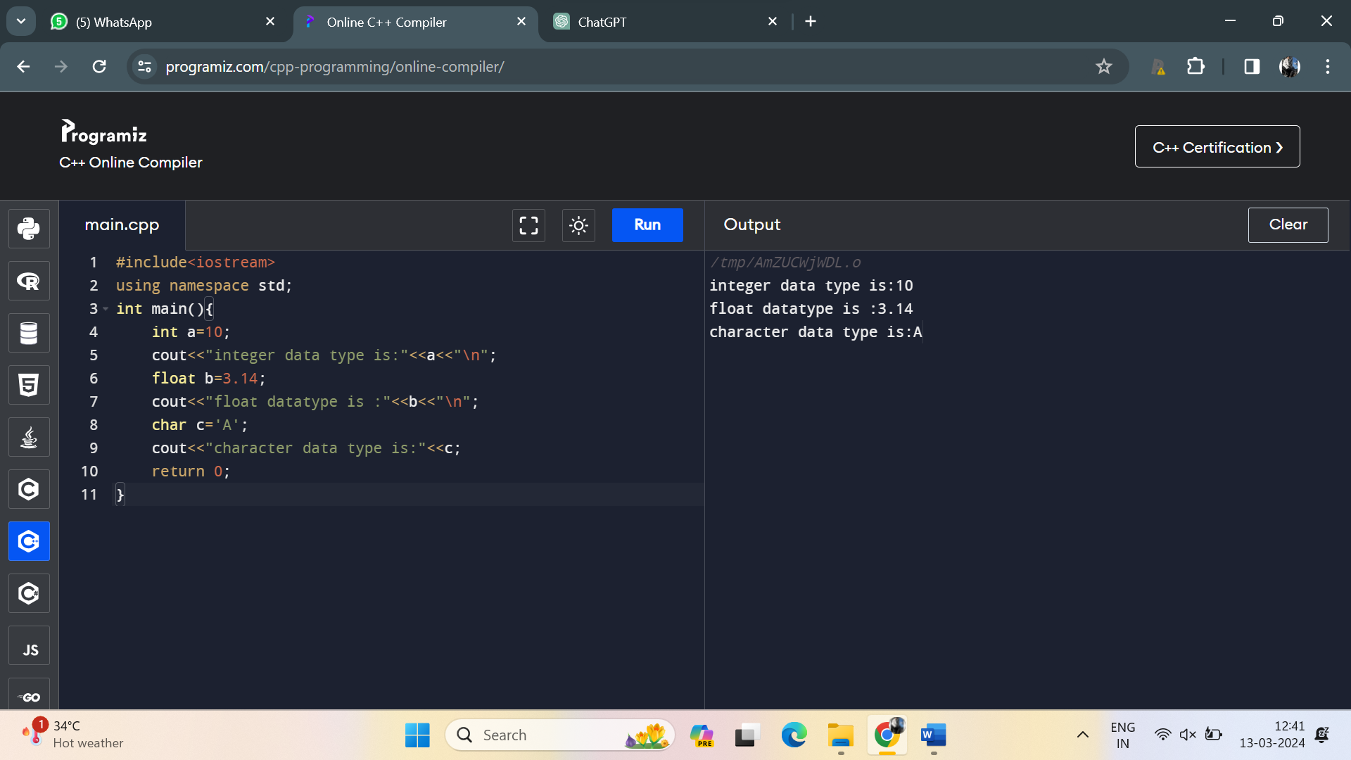

3. Create a C++ program to declare an integer variable and a float variable, then assign the integer variable to the float variable

**Program**:

#include<iostream>

using namespace std;

int main(){

int a=10;

float b;

b=static_cast<float>(a);

cout<<"integer value is:"<<a<<"\n";

cout<<"float value is :"<<b;

}

**Output**:

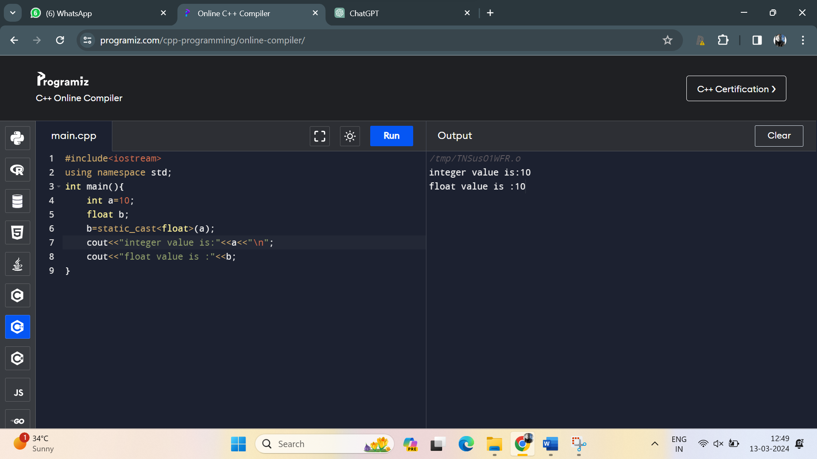

4. Implement a C++ program that performs an implicit conversion from integer to float

**Program**:

#include <iostream>

using namespace std;

int main() {

int myInteger = 42;

float myFloat = myInteger;

cout << "Integer value: " << myInteger << "\n";

cout << "Float value (after implicit conversion): " << myFloat ;

return 0;

}

**Output**:

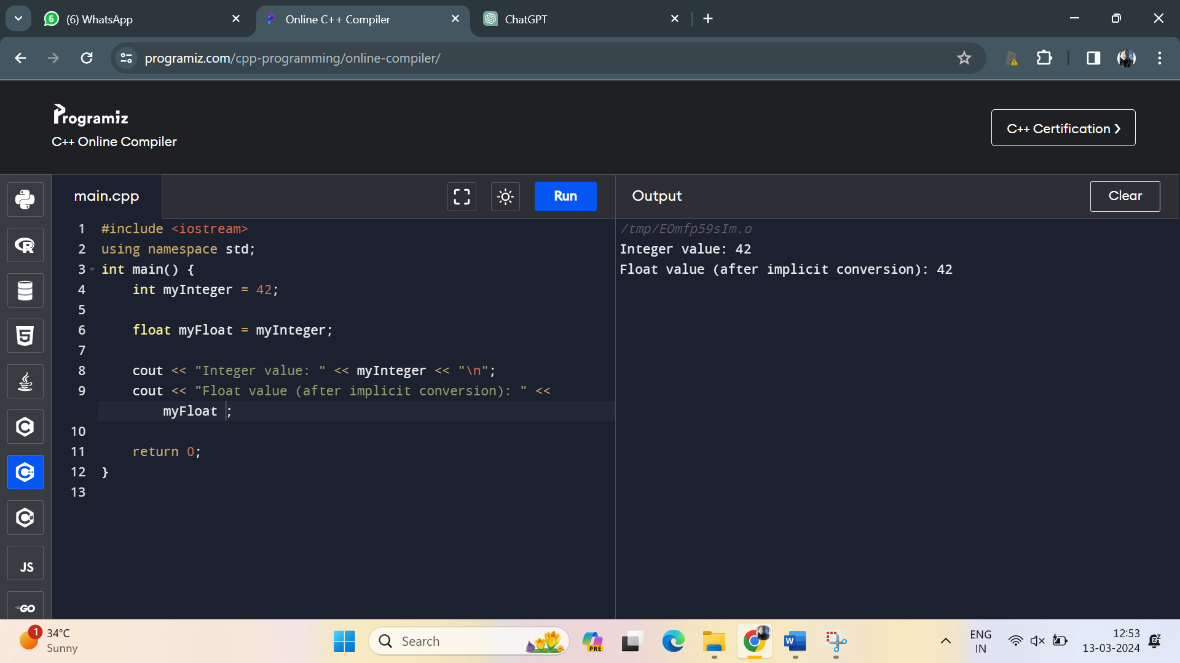

5. Write a C++ program to declare and initialize two integer variables and perform addition using the + operator

**Program**:

#include <iostream>

using namespace std;

int main() {

int a=10;

int b=20;

int sum=a+b;

cout<<"the sum is:"<<sum;

}

**Output**:

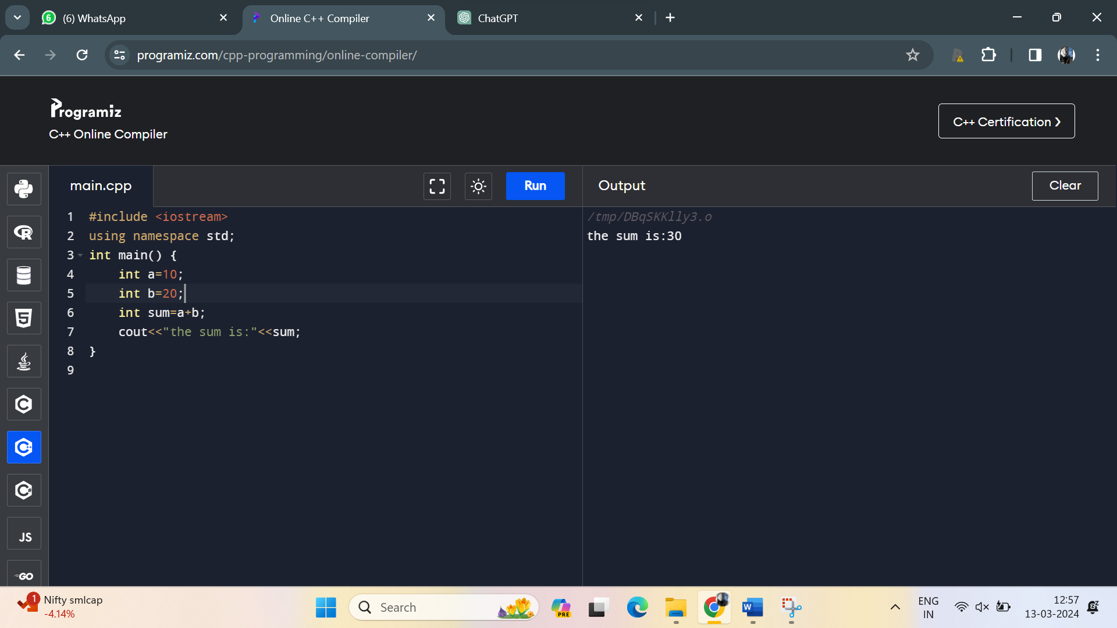

6. Create a C++ program to demonstrate the use of if-else control structure to determine if a number is even or odd

**Program**:

#include <iostream>

using namespace std;

int main() {

int a=10;

if(a%2==0)

{

cout<<"is an even number";

}

else

{

cout<<"is odd number";

}

}

**Output**:

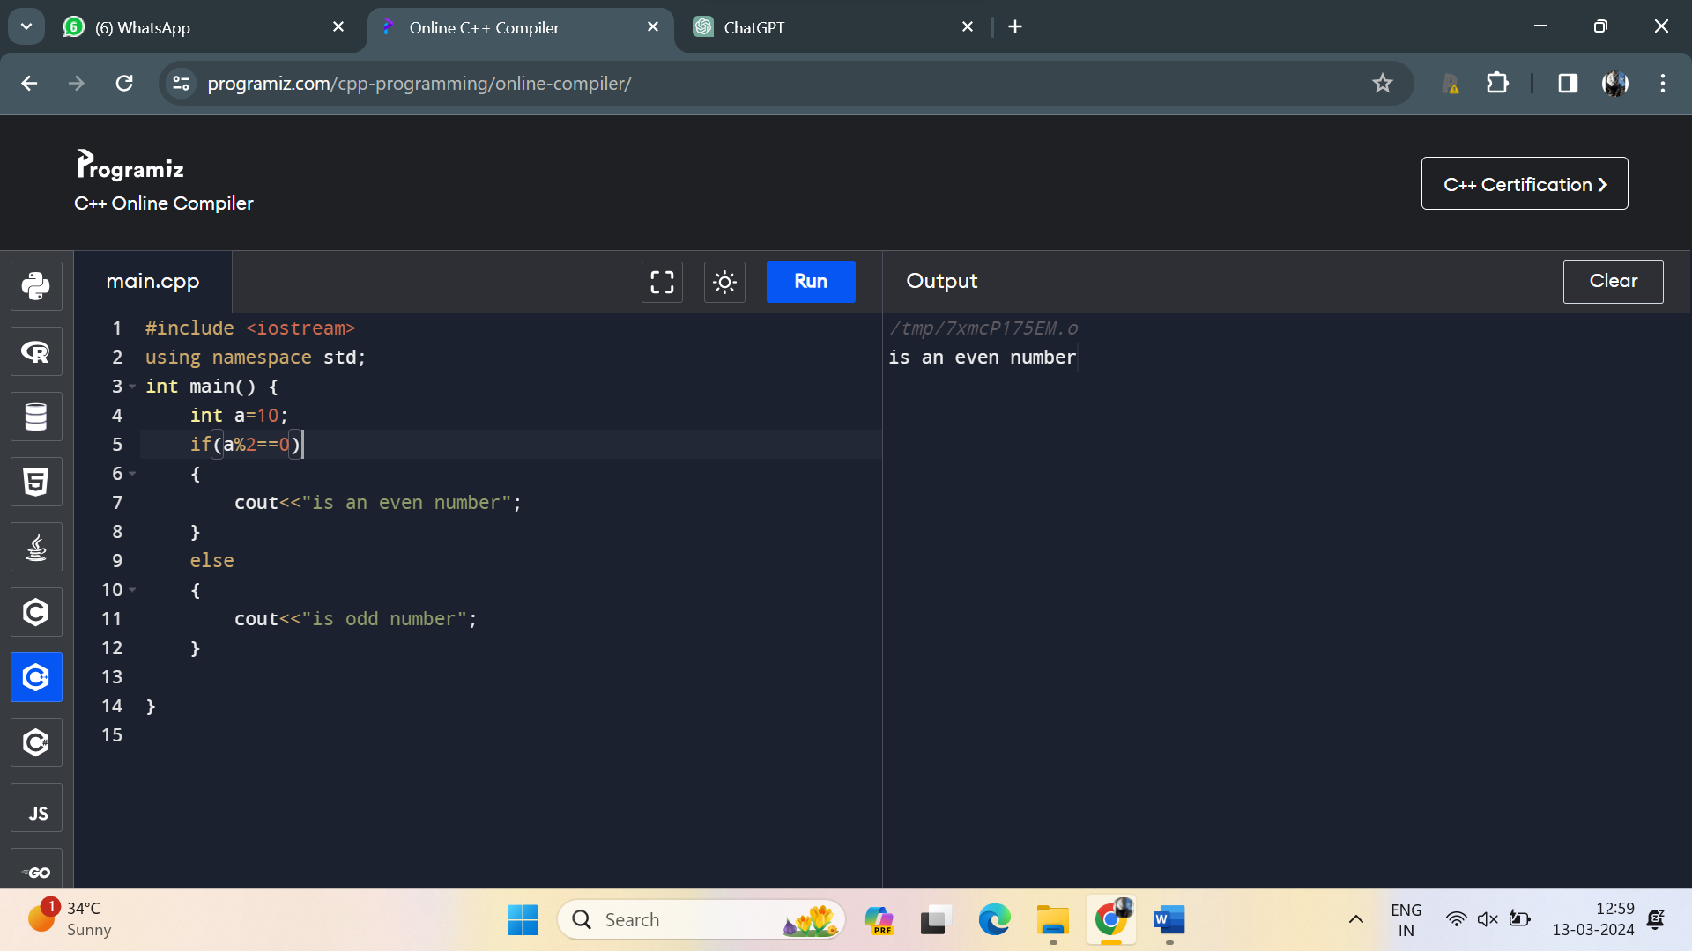

7. Write a C++ program to declare an array of integers and display its elements using a loop.

**Program**:

#include <iostream>

int main() {

const int arraySize = 5;

int myArray[arraySize] = {10, 20, 30, 40, 50};

std::cout << "Array elements:" << std::endl;

for (int i = 0; i < arraySize; ++i) {

std::cout << "Element " << i << ": " << myArray[i] << std::endl;

}

return 0;

}

**Output**:

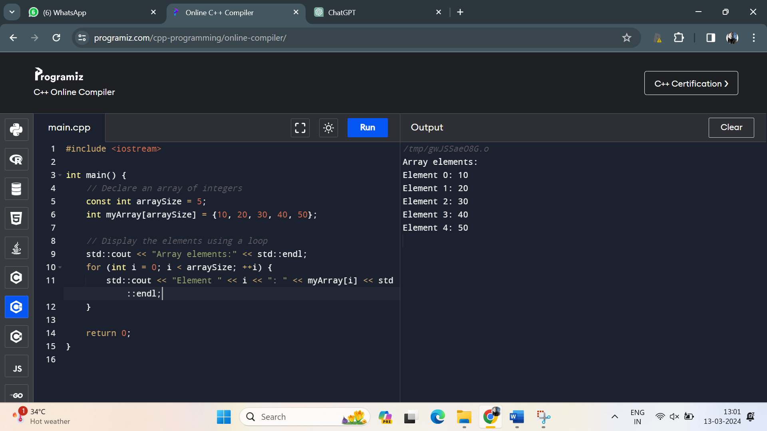

8. Implement a C++ program to demonstrate the use of switch-case control structure to display the name of the day based on the user input (1-7).

**Program**:

#include<iostream>

using namespace std;

int main(){

int n;

cout<<"enter the number between 1 to 7:";

cin>>n;

switch (n){

case 1:

cout<<"sunday"<<"\n";

break;

case 2:

cout<<"Monday"<<"\n";

break;

case 3:

cout<<"tuesday"<<"\n";

break;

case 4:

cout<<"wednsday"<<"\n";

break;

case 5:

cout<<"thursday"<<"\n";

break;

case 6:

cout<<"friday"<<"\n";

break;

case 7:

cout<<"saturday"<<"\n";

break;

}

return 0;

}

**Output**:

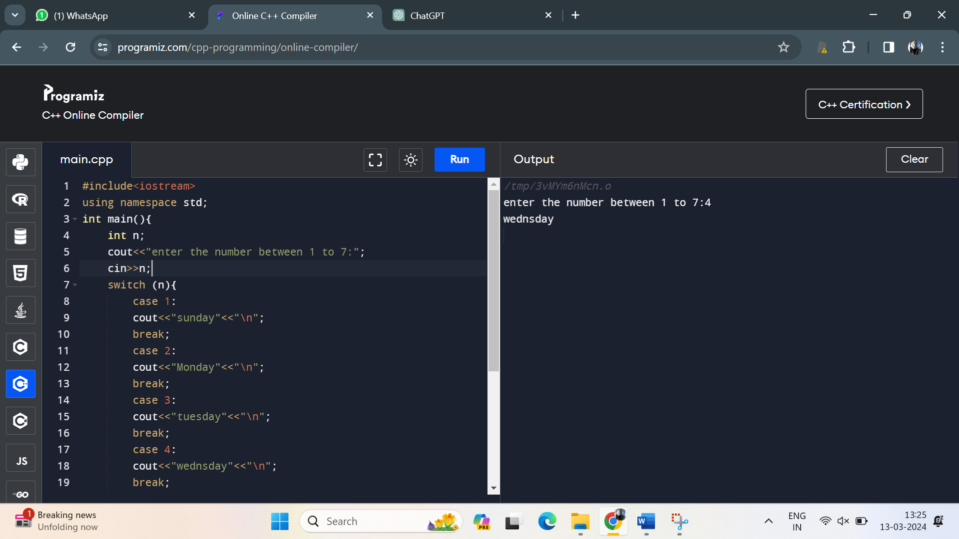

9. Create a C++ program to calculate the area of a rectangle using user input for length and width

**Program**:

#include<iostream>

using namespace std;

int main(){

int n=10;

int l=20;

int area=n*l;

cout<<"area of rectangle is:"<<area;

return 0;

}

**Output**:

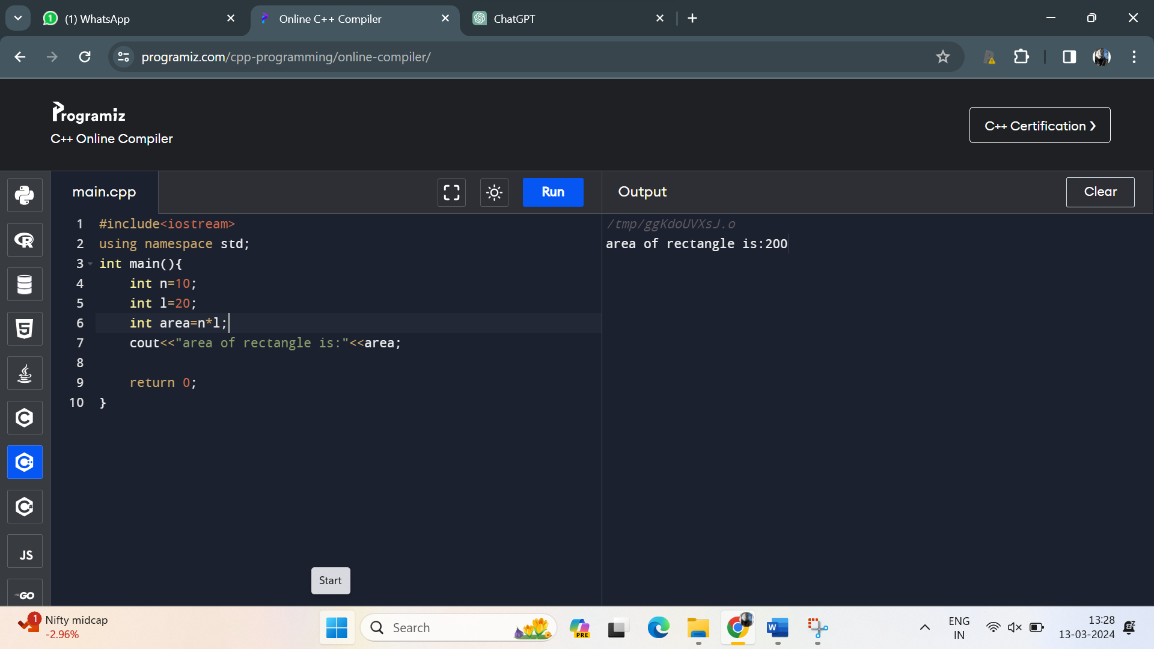

10. Write a C++ program to find the maximum of three numbers using conditional statements.

**Program:**

#include<iostream>

using namespace std;

int main() {

int num1, num2, num3;

cout << "Enter three numbers: ";

cin >> num1 >> num2 >> num3;

int maxNumber;

if (num1 >= num2 && num1 >= num3) {

maxNumber = num1;

} else if (num2 >= num1 && num2 >= num3) {

maxNumber = num2;

} else {

maxNumber = num3;

}

cout << "The maximum number is: " << maxNumber ;

return 0;

}

**Output**:

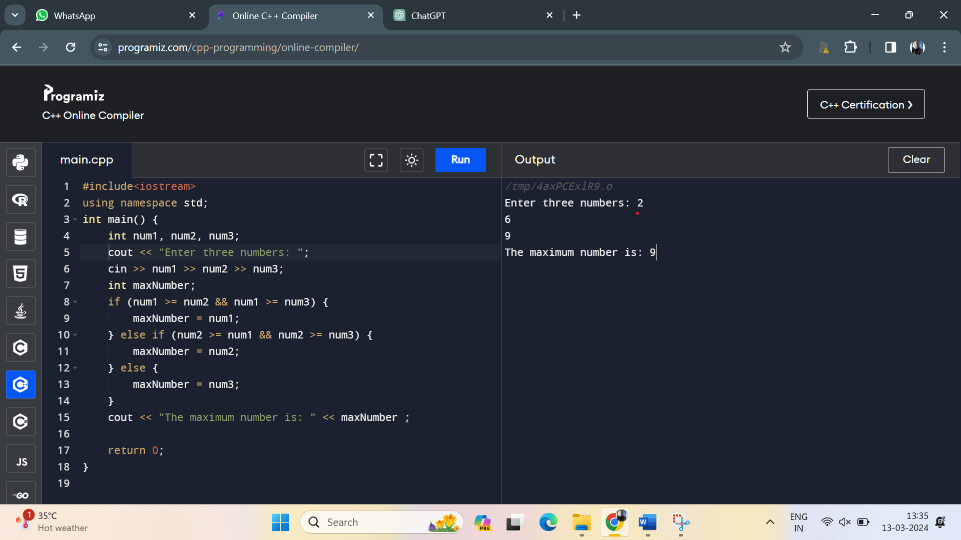

**Medium:**

111.Write a C++ program that calculates the area of a circle. Use a constant variable for the value of pi and prompt the user to enter the radius. Display the calculated area.

**Program:**

#include<iostream>

using namespace std;

int main(){

const double a=3.14;

int rad=5;

double area=a*rad*rad;

cout<<"the area of a circle is:"<<area;

return 0;

}

**Output**:

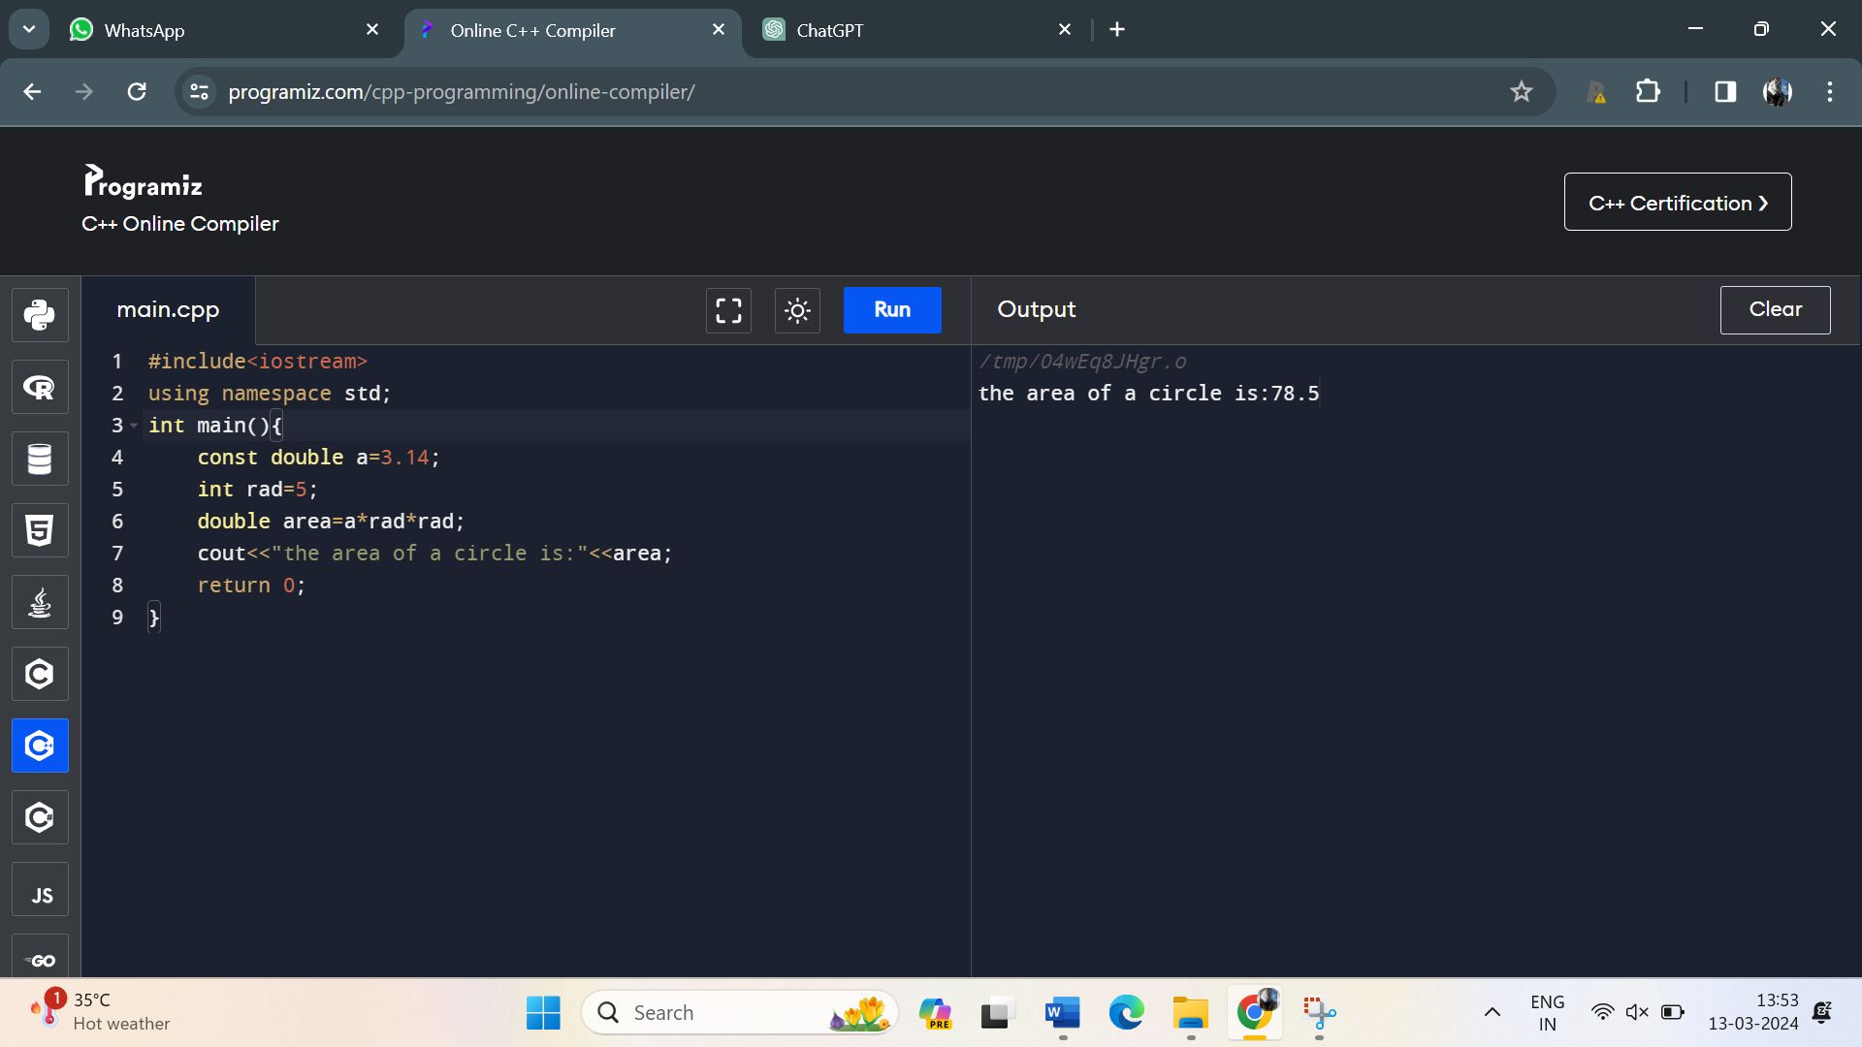

12. Develop a C++ program that reads two numbers from the user, one integer and one float. Perform division of the float by the integer and display the result. Ensure proper type compatibility and implicit conversion handling.

**Program:**

#include <iostream>

int main() {

int integerNumber;

float floatNumber;

std::cout << "Enter an integer: ";

std::cin >> integerNumber;

std::cout << "Enter a float: ";

std::cin >> floatNumber;

if (integerNumber != 0) {

float result = floatNumber / static_cast<float>(integerNumber);

std::cout << "Result of float / integer division: " << result << std::endl;

} else {

std::cout << "Error: Cannot divide by zero. Please enter a non-zero integer." << std::endl;

}

return 0;

}

Output:

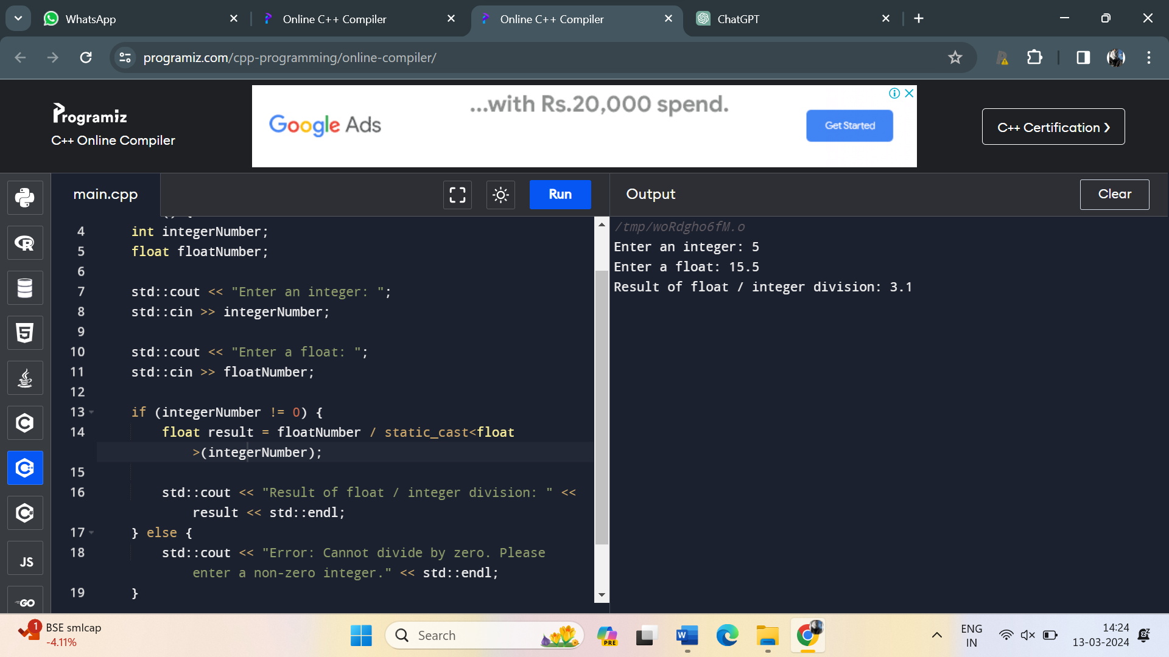

13. Write a C++ program to determine whether a given year is a leap year or not. Use logical operators and appropriate control structures to implement the leap year logic.

**Program:**

#include <iostream>

int main() {

int year;

std::cout << "Enter a year: ";

std::cin >> year;

if ((year % 4 == 0 && year % 100 != 0) || (year % 400 == 0)) {

std::cout << year << " is a leap year." << std::endl;

} else {

std::cout << year << " is not a leap year." << std::endl;

}

return 0;

}

**Output**:

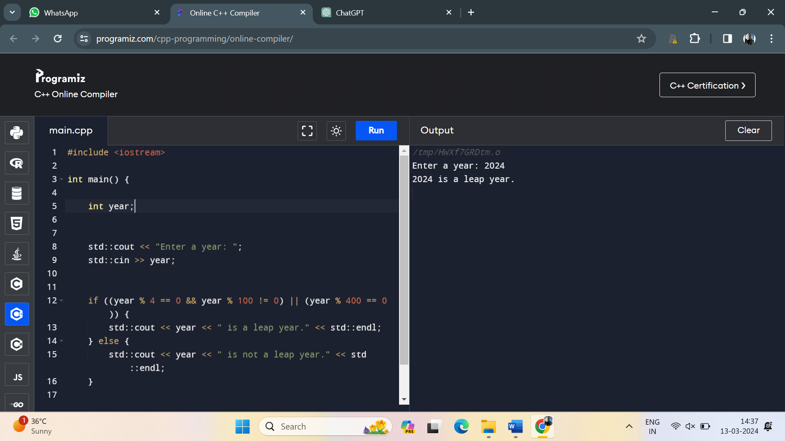

14. Create a C++ program that calculates the area of a rectangle. Prompt the user to enter the length and width of the rectangle as floating-point numbers, and display the calculated area.

Program:

#include <iostream>

int main() {

double length, width;

std::cout << "Enter the length of the rectangle: ";

std::cin >> length;

std::cout << "Enter the width of the rectangle: ";

std::cin >> width;

double area = length * width;

std::cout << "The area of the rectangle with length " << length

<< " and width " << width << " is: " << area << std::endl;

return 0;

}

Output:

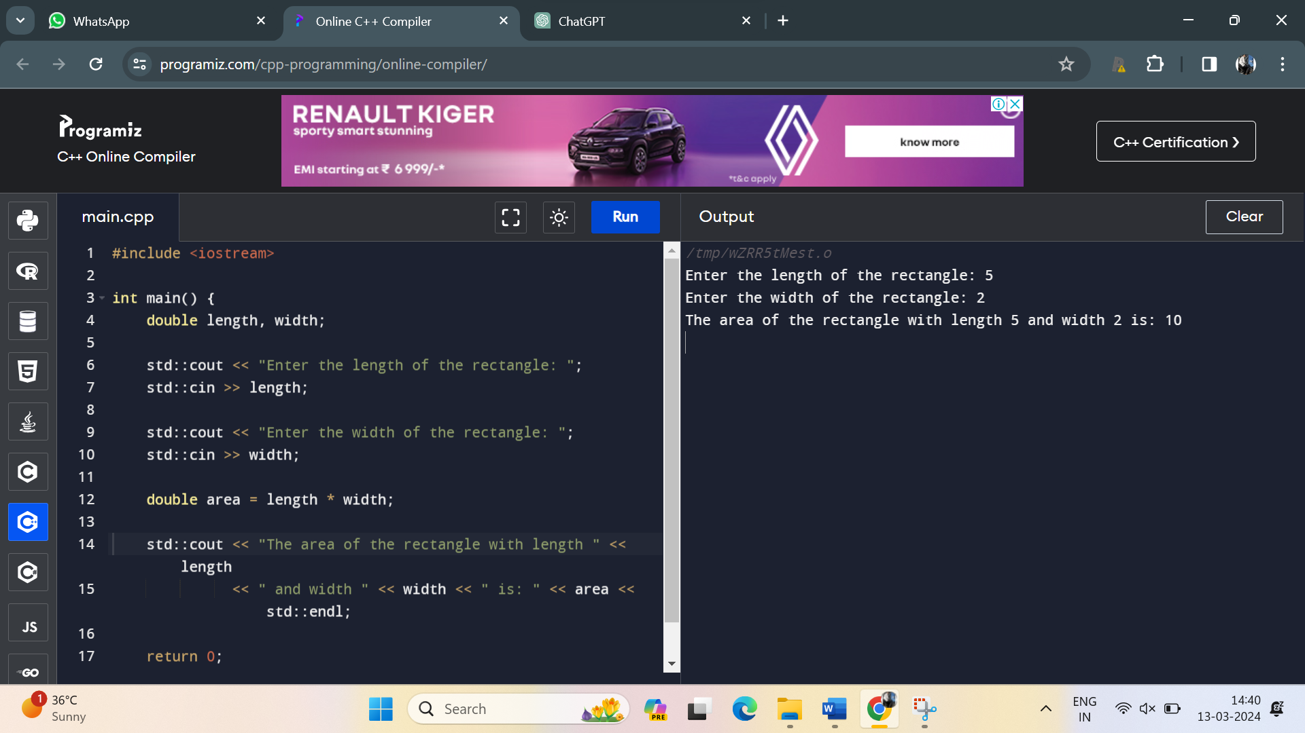

15. Develop a C++ program that reads an integer from the user and checks if it is an odd number. Use bitwise AND operator and handle implicit conversion properly.

Program:

#include <iostream>

int main() {

int userInput;

std::cout << "Enter an integer: ";

std::cin >> userInput;

if (userInput & 1) {

std::cout << userInput << " is an odd number." << std::endl;

} else {

std::cout << userInput << " is an even number." << std::endl;

}

return 0;

}

Output:

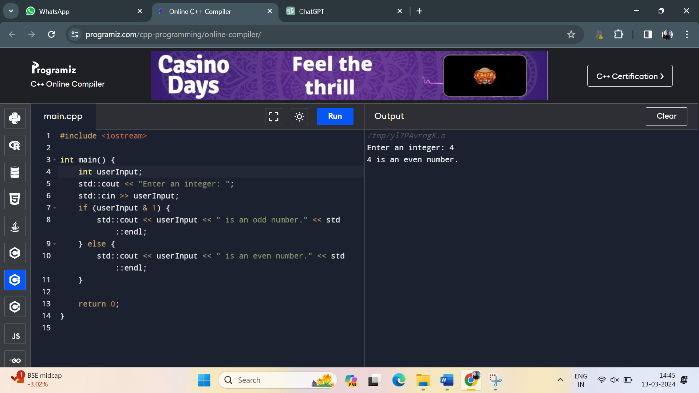

16. Write a C++ program that prompts the user to enter a month number (1-12) and displays the corresponding month name. Use a switch-case statement to implement this.

**Program:**

#include<iostream>

using namespace std;

int main(){

int n;

cout<<"enter the number:";

cin>>n;

switch (n){

case 1:

cout<<"january";

break;

case 2:

cout<<"Fiburary";

break;

case 3:

cout<<"March";

break;

case 4:

cout<<"Apriel";

break;

case 5:

cout<<"May";

break;

case 6:

cout<<"jun";

break;

case 7:

cout<<"july";

break;

case 8:

cout<<"August";

break;

case 9:

cout<<"September";

break;

case 10:

cout<<"October";

break;

case 11:

cout<<"November";

break;

case 12:

cout<<"December";

break;

}

return 0;

}

Output:

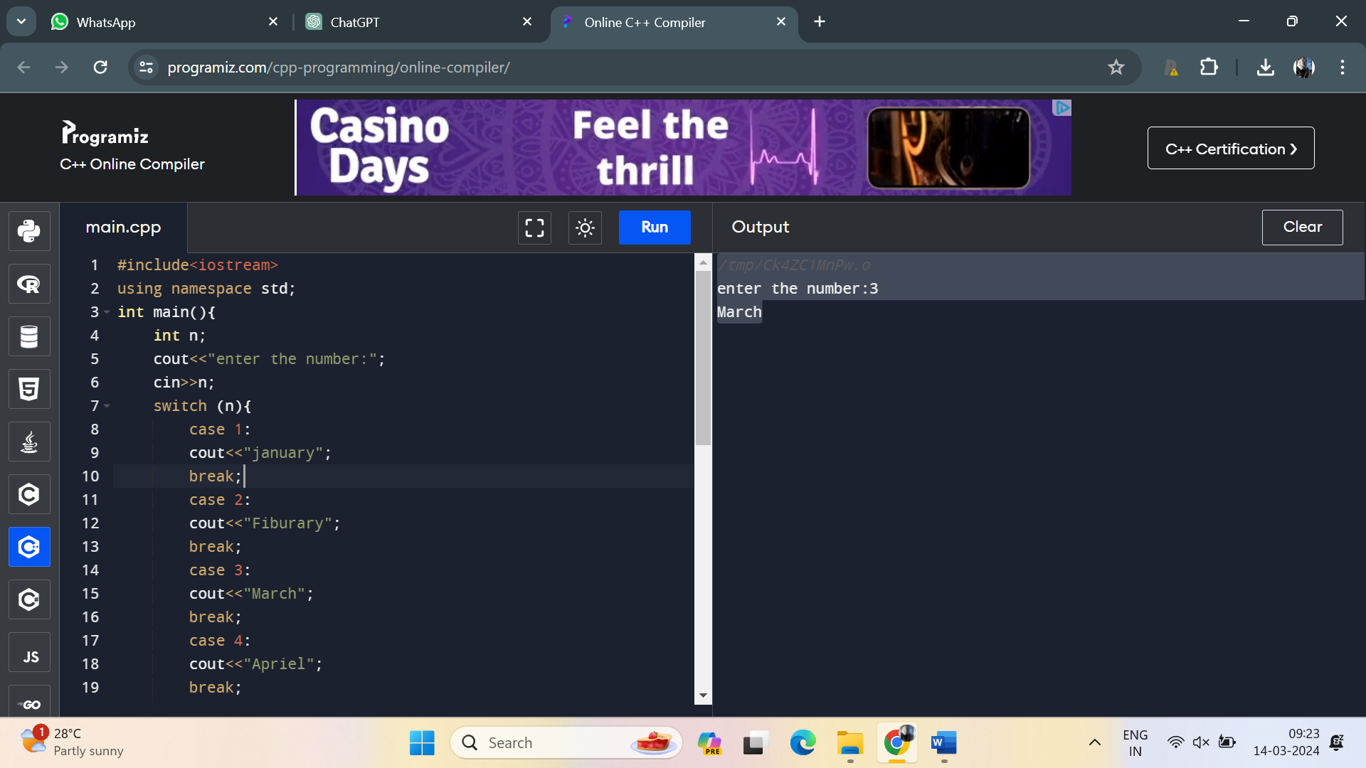

17. Create a C++ program that calculates the volume of a sphere. Prompt the user to enter the radius and use a constant variable for the value of pi. Display the calculated volume.

**Program:**

#include <iostream>

#include <cmath>

using namespace std;

int main() {

const double pi = 3.14159;

double radius, volume;

cout << "Enter the radius of the sphere: ";

cin >> radius;

volume = (4.0 / 3.0) * pi * pow(radius, 3);

cout << "The volume of the sphere is: " << volume << endl;

return 0;

}

Output:

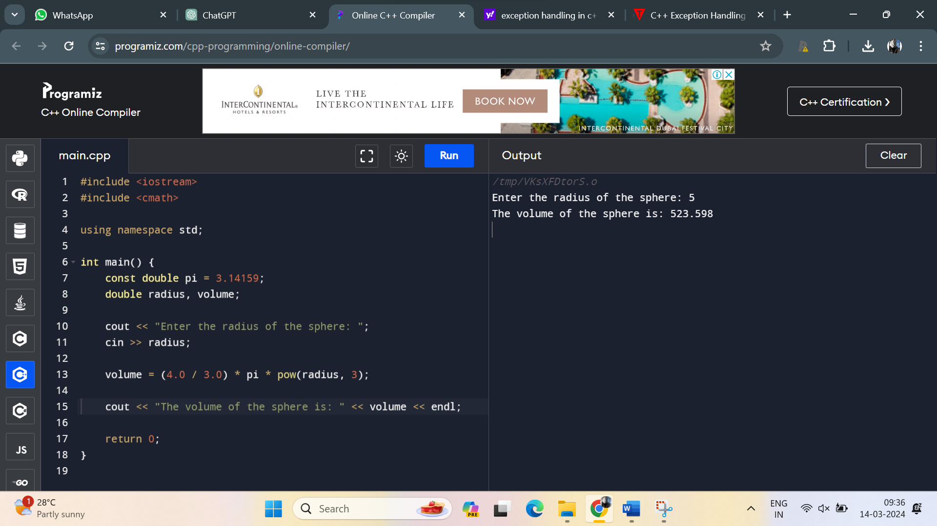

18. Develop a C++ program that reads two integers from the user and performs division. Ensure that if the second number is zero, the program should not crash, but display an appropriate error message

Program:

#include <iostream>

using namespace std;

int main() {

int dividend, divisor;

double result;

cout << "Enter the dividend: ";

cin >> dividend;

cout << "Enter the divisor: ";

cin >> divisor;

if (divisor == 0) {

cout << "Error: Division by zero is not allowed." << endl;

} else {

result = static_cast<double>(dividend) / divisor;

cout << "Result of division: " << result << endl;

}

return 0;

}

Output:

